INTRODUCTION TO COMPUTER VISION

Introduction:
When machines begin to see, the world transforms into data— and data becomes insight. Human vision has always been an essential sense, allowing people to interact with their environment. But what happens when machines learn to see?
This transformation is what we call computer vision—the ability for machines to interpret and understand images, not just capture them.
Computer vision is more than simple image recognition. It’s about understanding objects, their relationships, and their significance. It’s about giving machines the ability to think visually, much like we do.
Imagine a world where cameras don’t just take pictures but detect facial expressions, recognize objects, and even predict actions. We’re heading toward a future where AI-powered vision can drive innovation in medicine, agriculture, security, and exploration.

The Evolution of Computer Vision:
The first cameras changed history, but they had major limitations:
- Early photography required long exposure times—sometimes eight hours just to capture a single image!
- Subjects had to remain perfectly still, leading to stiff, unnatural expressions in portraits.
- Cameras could capture scenes but couldn’t interpret them.
Fast forward to today. Modern cameras combined with AI-driven computer vision are capable of recognizing faces, objects, movement, and even emotions.
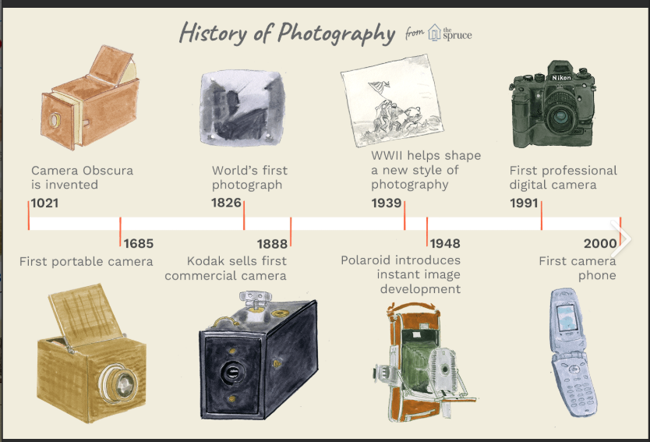
Think about it:
- Surveillance systems can now track activity and detect threats.
- Autonomous vehicles can “see” obstacles and navigate roads.
- Smartphone cameras recognize faces for secure authentication.
This technological leap is possible because of deep learning models like Convolutional Neural Networks (CNNs), which mimic the way human brains process visual data.

How Machines Learn to See:
Computer vision is powered by three essential steps:
1️. Capturing an Image: The process begins with a machine taking a digital image, whether from a camera, a microscope, or even a satellite.

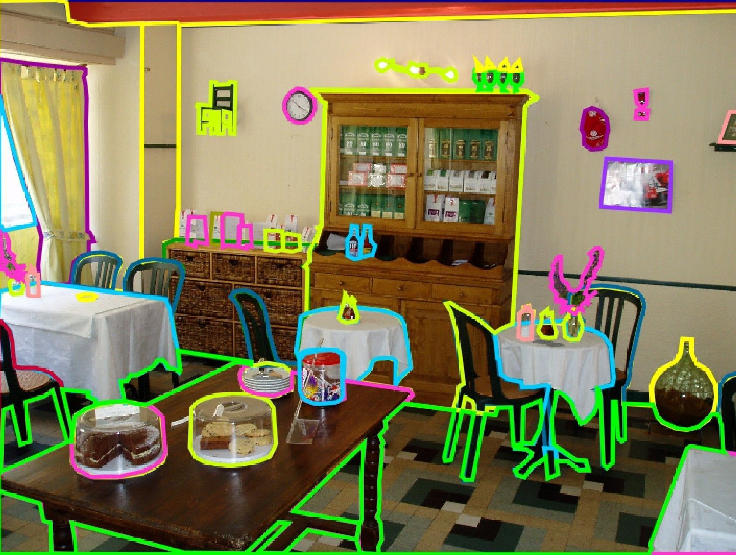
2️. Processing the Image with Mathematical Algorithms: AI enhances, filters, and analyzes the image. Complex neural networks find patterns and extract important details.
3️. Recognizing Objects & Interpreting Meaning: The machine labels the detected object—whether it's a face, a fruit, or an animal.
This process enables AI not just to see but to understand, allowing it to differentiate between:
- A banana or a croissant
- A smiling dog or a dangerous slipper
- A boss’s reflection or an actual person
While human vision is instinctive, machines must learn through massive datasets and deep learning models. With every image analyzed, AI gets better at identifying and predicting patterns.
Real-World Applications:
Computer vision is revolutionizing industries:
Space Exploration
- NASA uses AI-powered vision to analyze images from Mars rovers and identify geological formations.
Healthcare
- AI assists in medical imaging, detecting tumors and diagnosing diseases with higher accuracy than traditional methods.
Agriculture
- Smart cameras monitor crop health, identify pests, and help farmers optimize irrigation and harvesting cycles.
Beyond industries, computer vision enhances everyday life:
Social media platforms use facial recognition for tagging friends.
Self-driving cars rely on real-time visual data to safely navigate roads.
Smartphones unlock using face detection algorithms.
The ability of machines to interpret their surroundings is pushing technology beyond human limitations.

The Future of Computer Vision:
What’s next in the field of AI-powered vision?
Predictive Vision
- AI will not just see objects but predict interactions—detecting risks before they happen.

Hyper-Intelligent Surveillance
- Security cameras will automatically detect abnormal behavior and send alerts in real-time.
Global Accessibility
- AI vision tools will assist the visually impaired, enabling real-time voice descriptions of surroundings.
The fusion of AI and vision will continue to reshape industries, helping machines become more intuitive, proactive, and intelligent. We are entering a new era—one where machines truly understand what they see.

